ECSEL JU proudly presents state-of-the-art innovations at the R&I Days in Brussels

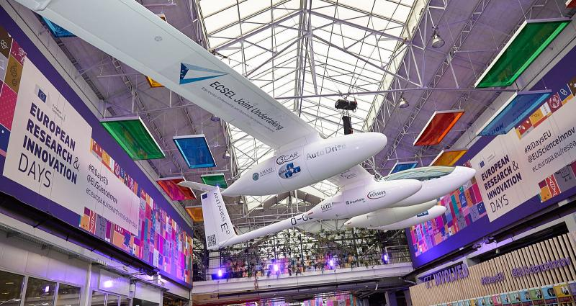

ECSEL Joint Undertaking was invited to showcase a few remarkable projects results during the European Research & Innovation Days 2019, the annual policy event of the European Commission taking place between 24-26 September 2019 in Kanal-Center Pompidou in Brussels. More than 3000 people attended each of the three R&I Days, including Europe’s best and brightest researchers, scientists, innovators and policy makers. The participants debated over the future landscape of science and research in the context of Horizon Europe, the next European Union framework programme for research and innovation and were able to see various real-life results of research achieved within the Horizon 2020.

The 26 projects featuring in the WOW Exhibition of the R&I Days were carefully selected out of thousands of completed or ongoing H2020 research projects, to best present the various science achievements done in Europe and their tangible results. ECSEL JU was honored to present several of our projects and highlight their impressive benefits for Europe’s economy and a sustainable and successful society. Together with projects representatives, we presented four ongoing projects:

* COMP4DRONES, a new project in our portfolio, developing the ecosystem of electronic components for safe & autonomous drones;
* AutoDrive, an impressive 3-year project creating components, systems and architectures for highly- and fully-automated driving;
* PRYSTINE, realizing Fail-operational Urban Surround perception for safe, automated driving in urban and rural environments;
* and VI-DAS, improving the road safety by development and deployment od advanced driver-assistance systems.

In addition, a spectacular electric-powered glider had pride of place in the main hall area. This glider includes work from several ECSEL JU projects as well as projects in Horizon 2020, meant to demonstrate solutions for the safety issues in electric and autonomous electric vehicles. Like the Vi-DAS car, it demonstrates the power of collaboration between projects, even from different funding schemes.

 Each of these projects brought great interactive demonstrators and explained their main goals and objectives to exhibition visitors, which included several notable names, such as Mrs Maria da Graça Carvalho, MEP, Mr Nicolae Hurduc, the Romanian Minister of Research & Innovation, Mr Krasimir Valchev, the Minister of Science and Education in Bulgaria, and many more.